Instrumentation refers to measuring process variables such as flow or water levels. Control refers to the act of regulating these parameters using instruments such as sensors and valves. Digital instrumentation and control (I&C) systems can be classified broadly as control systems (e.g. feed-water control system) and protection systems (e.g. reactor protection system). These systems are installed in new nuclear power plants (NPP) and as part of upgrades to older plants. Failures in the systems could either be in hardware or software. There could be random hardware failures, but random software faults are less likely (Chu et al., 2010a). While hardware failures can be modeled probabilistically, software failures can also be modeled in the same way assuming that the faults caused in software are due to an underlying cause in the digital system. Some common digital system components are analog/digital (A/D) converter, microprocessor, digital/analog (D/A) converter etc. The failure of an I&C system could lead to core damage or release of radioactive substances.

A key issue of Probabilistic Risk Analysis (PRA) is to identify potential failure modes, effects and hazards of digital I&C systems. Failure Modes Effects Analysis (FMEA) can be used to support development of system reliability models. It aids in identifying hardware and software interactions in sufficient detail. But, there is no well established definition of a digital failure mode (Chu et al., 2010b).

Reliability is a result of features like fault tolerance, fault coverage, fail safe, redundancy, defense-in-depth and diversity of components. Digital system reliability models either account for hardware and software failures separately or take both in to consideration in a single model. Software failures could potentially impact the performance of mitigating systems. Certain failure modes could arise due to software which was not originally considered for analog systems (Chu et al., 2010a). Hence digital system reliability modeling is an area of research in itself. Regulatory bodies do not have standards or guidance documents exclusively on modeling these systems (Chu et al., 2010a). The Dynamic Flowgraph Methodology (DFM) and Markov modeling method have been identified as top two methods for modeling DIC systems.

The technical report by Aldemir et al. (2006) explored various methods available for system reliability evaluation of digital I&C systems. Static fault tree and event tree approaches were considered obsolete due to the inherent inability of these methods to tackle “dynamic interaction” between digital systems and rest of the plant processes. An example of such an interaction is a competition between two tasks to get hold of a digital controller’s resources. Deadlock could be a situation when two threads wait for each other to release resources they are in control of. Starvation is a situation where a low priority thread might have to wait indeﬁnitely for the controller’s time slice. Hence temporal interactions could lead to dynamic situations and these can be handled well using state transition methods by branching diﬀerent situations as distinct states. Despite the provisions for specialized dependency gates, the dynamic fault tree (DFT) method (Rao et al., 2009) has the shortcoming that the generated cutsets might change as the system evolves in time.

The dynamic ﬂowgraph methodology, DFM (Al-Dabbagh and Lu, 2010) is yet another contestant for modelling reliability of digital I&C embedded systems. It takes the directed graph approach with decision tables for state transitions, edges for failure dependencies and nodes for variables (.e.g., Water level, Valve position). Nodes can have discrete states (e.g., High, Stationary, Low). The decision table construction involves all possible mappings of variables and corresponding states (e.g., Water level high and valve open). The mapping must also account for various switching actions for backup solutions. Yau et al. (1995) demonstrated the use of DFM for a digital flight control system where 9 input variables with 5 states each led to 5⁹ rows in the decision table. The paper worked around the problem by using equations of motion and control laws thus bypassing the construction and lookup of the decision table. Hence decision table construction could potentially encounter a dimensionality problem and modeling would not adhere to a universal solution. Lack of methods for systematically modelling systems, explosive combinatorics and excessive computational demand are the odds against the application of the DFM methodology though it has the ability to model multiple top events. Stochastic petri nets (Kleyner and Volovoi, 2010) is also a graph theoretic approach whose quantiﬁcation can be done using simulation. These models can be converted to fault trees, but size of the model and simulation speed could severely prohibit their usage for digital I&C systems.

Another technical report by Aldemir et al. (2007) concentrated exclusively on reliability modelling of digital I&C systems for nuclear reactor probabilistic risk assessments. Markov models were developed for various controllers and computer systems of the digital feedwater controller system (DFWCS). These include the main feedwater regulating valve (MFV) controller, the bypass feedwater regulating valve (BFV) controller, the feedwater pump (FP) controller, the pressure drop indicator (PDI) controller, power source of these controllers and finally the main and its backup computers. This report was at large a proof-of-concept for the use of Markov models for digital systems. The state space for the models were elaborately developed and then reduced according to state reduction principles for practical applications. Aldemir et al. (2010) reﬁned and quantiﬁed some of these models by generating Markov transition rates using fault injection techniques. Such techniques in software testing widen the scope of test data by introducing deliberate faults in the system.

A broad overview of probabilistic safety assessment for digital I&C systems in the areas of quality assurance, surveillance testing and I&C design is given by Lu and Jiang (2004). Clarotti and Mattucci (1980) carried out reliability analysis of a computerized nuclear reactor protection system. The paper chose Markov model for the task assuming the following as random variables: time to detectable and undetectable computer failure, time to reactor trip and startup and also the time to detect a detectable failure. The model consisted of eleven states with the aim of evaluating accident probability in the plant. The states were determined based on two minicomputers and the protection and self-checking programs running on them.

Dynamic interactions and common cause failures (CCF) must be considered in digital I&C reliability models. CCFs could occur either due to the operating system (OS) or the application software (Shi et al., 2010). While an OS failure could lead to failure of all processing computers, application software failure could affect related software functionality. CCF failure rates for reliability analysis are often subjectively assigned based on the quality of software development life cycle. Fault injection techniques have also been explored to generate failure data though these may not be as effective as field data.

Availability of raw hardware failure data is scare and hence expert judgment is often used to evaluate models with failure dependencies. Where possible, operating history, maintenance documentation and event reports are used as data sources (Chu et al., 2010a). Classical and Bayesian techniques are used to estimate the model specific parameters. Theoretical failure rates could be gathered from design and prototype phase of hardware products.

Digital systems could fail due to human errors as well. These could be due to a software upgrade or faulty human-system interface (Chu et al., 2010a).
Example: The digital feedwater controller system (DFWCS)

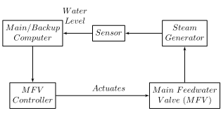
Figure 1. Interaction within the digital feed water control system (DFWCS)

The digital feed water control system (DFWCS) is responsible for regulating water level in the steam generator. A water level sensor outputs level to the computer. The computer then determines the amount by which the valves need to be repositioned so as to adjust the water ﬂow speed. This information is sent in the form of a signal to the controller. Accordingly, the controller actuates the main feedwater regulating valve (MFV) to optimize the water ﬂow. A section of the DFWCS is shown in Figure 1.
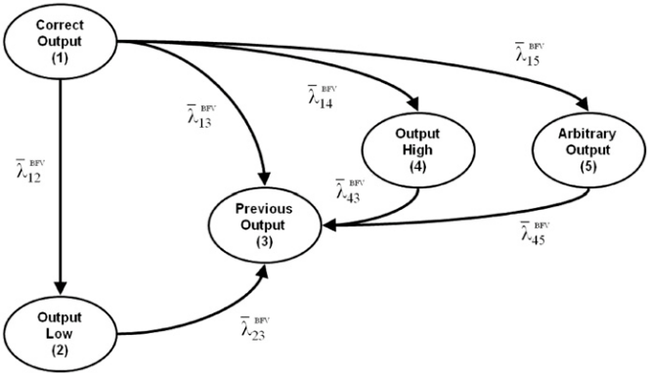
Figure 2. Markov transition diagram for the MFV, BFV, and FP controllers. Source: Aldemir et al. (2010)

There is a ﬁnite probability of the valve getting stuck in its maximum or minimum ﬂow position due to an erroneous output from the controller. It is also possible that the controller sends an arbitrary or random output to the valve. These could be due to a processing error or an internal problem in the computer. In these abnormal cases the controller feeds a valid previous output to the valve and is termed as the failure of the controller system. The various output cases are represented as states in the Markov model (Figure 2). The BFV and FP controllers also share the same Markov model.

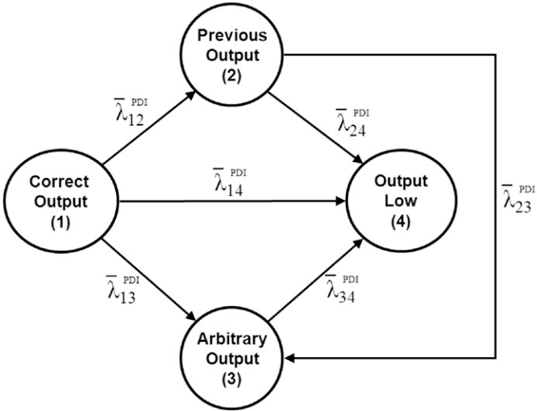
Figure 3. Markov transition diagram for the PDI controller. Source: Aldemir et al. (2010)

The PDI controller acts as a backup for the MFV controller and has four possible states in its Markov model as seen in Figure 3. It periodically samples the output of the MFV controller and stores the last valid output for a potentially adverse situation.
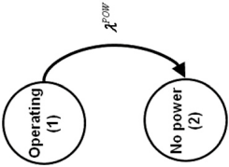
Figure 4. Markov transition diagram for the power source of the MFV, BFV, and FP. Source: Aldemir et al. (2010)

The power source for the MFV, BFV and FP controllers has binary states as in Figure 4.

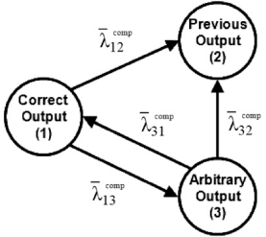
Figure 5. Markov transition diagrams for the computers. Source: Aldemir et al. (2010)

Finally, the Markov model for main and backup computers is shown in Figure 5. The high and low output states are not needed in the model as the computer can correct the output as needed. However, there could be an arbitrary output due to unexpected behavior of the software components.

Out of a year, the operational mission time of the DFWCS is assumed to be 11 months allowing for one month of outage time (Aldemir et al., 2006). For PRA purposes, the usual (default) reference time period is 24h Aldemir et al. (2010).

The individual dynamic reliability Markov models were integrated in to an existing PRA model using event/fault tree feature of SAPHIRE software. Since the rate of arbitrary output cannot be determined, a sensitivity analysis was conducted assuming a random value between 0 and 1. The sequence of failure probabilities thus obtained for a time period of 24h was averaged and confidence intervals were built leading to a low and high DFWCS failure probability of 4.963 x 10⁻⁴ and 7.460 x 10⁻⁴ respectively.

References:
Al-Dabbagh, A. W. and Lu, L. (2010). Reliability modeling of networked control systems using dynamic ﬂowgraph methodology. Reliability Engineering & System Safety, 95 (11), 1202 – 1209.

Aldemir, T., Guarro, S., Mandelli, D., Kirschenbaum, J., Mangan, L., Bucci, P., Yau, M., Ekici, E., Miller, D., Sun, X. and Arndt, S. (2010). Probabilistic risk assessment modeling of digital instrumentation and control systems using two dynamic methodologies. Reliability Engineering & System Safety, 95 (10), 1011 – 1039.

Aldemir, T., Miller, D., Stovsky, M., Kirschenbaum, J., Bucci, P., Fentiman, A. W. and Mangan, L. (2006). NUREG/CR-6901: Current state of reliability modeling methodologies for digital Systems and their acceptance criteria for Nuclear power plant assessments. Tech. rep., Washington, DC, US Nuclear Regulatory Commission.

Aldemir, T., Stovsky, M., Kirschenbaum, J., Mandelli, D., , Bucci, P., Mangan, L., Miller, D., Sun, X., Ekici, E., Guarro, S., Yau, M., Johnson, B.,Elks, C. and Arndt, S. (2007). NUREG/CR-6942:Dynamic Reliability Modeling of Digital Instrumentation and Control Systems for Nuclear Reactor Probabilistic Risk Assessments. Tech. rep., Washington, DC, US Nuclear Regulatory Commission.

Chu, T., Martinez-Gurdi, G., Kuritzky, A., and Amri, A. (2010a). International Experience with Modeling Digital Systems in PSAs. Proc. of the 10th International Probabilistic Safety Assessment & Management Conference, Seattle, Washington, USA.

Chu T., Yue, M., Martinez-Guridi, G., and Lehner, J. (2010b). A Generic Failure Modes and Effects Analysis (FMEA) Approach for Reliability Modeling of Digital Instrumentation and Control (I&C) Systems. Proc. of the 10th International Probabilistic Safety Assessment & Management Conference, Seattle, Washington, USA.

Clarotti, C. A. and Mattucci, A. (1980). Safety assessment for computerized nuclear reactor protection systems: The markov approach. Nuclear Engineering and Design, 58 (3), 349–358.

Kleyner, A. and Volovoi, V. (2010). Application of petri nets to reliability prediction of occupant safety systems with partial detection and repair. Reliability Engineering & System Safety, 95 (6), 606 – 613.

Lu, L. and Jiang, J. (2004). Probabilistic safety assessment for instrumentation and control systems in nuclear power plants: An overview. Journal of Nuclear Science and Technology, 41 (3), 323–330.

Rao, K. D., Gopika, V., Rao, V. S., Kushwaha, H., Verma, A. and Srividya, A. (2009). Dynamic fault tree analysis using monte carlo simulation in probabilistic safety assessment. Reliability Engineering & System Safety, 94 (4), 872 – 883.

Shi, L., Enzinna, R., Yang, S. and Blodgett, S. (2010). Probabilistic Risk Assessments of Digital I&C in Nuclear Power Plant. Proc. of the 10th International Probabilistic Safety Assessment & Management Conference, Seattle, Washington, USA.

Smith, C. L., Knudsen, J., Calley, M., Beck, S., Kvarfordt, K., Wood, S.T. (2005). SAPHIRE Basics: an introduction to probability risk assessment via the systems analysis program for hands-on integrated reliability evaluations (SAPHIRE) software, Idaho National Laboratory, Idaho Falls, USA.

Yau, M., Guarro, S., Apostolakis, G. (1995). Demonstration of the Dynamic Flowgraph Methodology using the Titan II Space Launch Vehicle Digital Flight Control System. Reliability Engineering & System Safety, 49 (3), 335-353

Glossary:
Fault coverage: Percentage of faults that can be detected during testing of a digital system.
Fault tolerance: The ability of a system to continue operation in the event of a failure.
Fail safe: A feature in a digital system that minimizes harm to devices in the event of failure.

